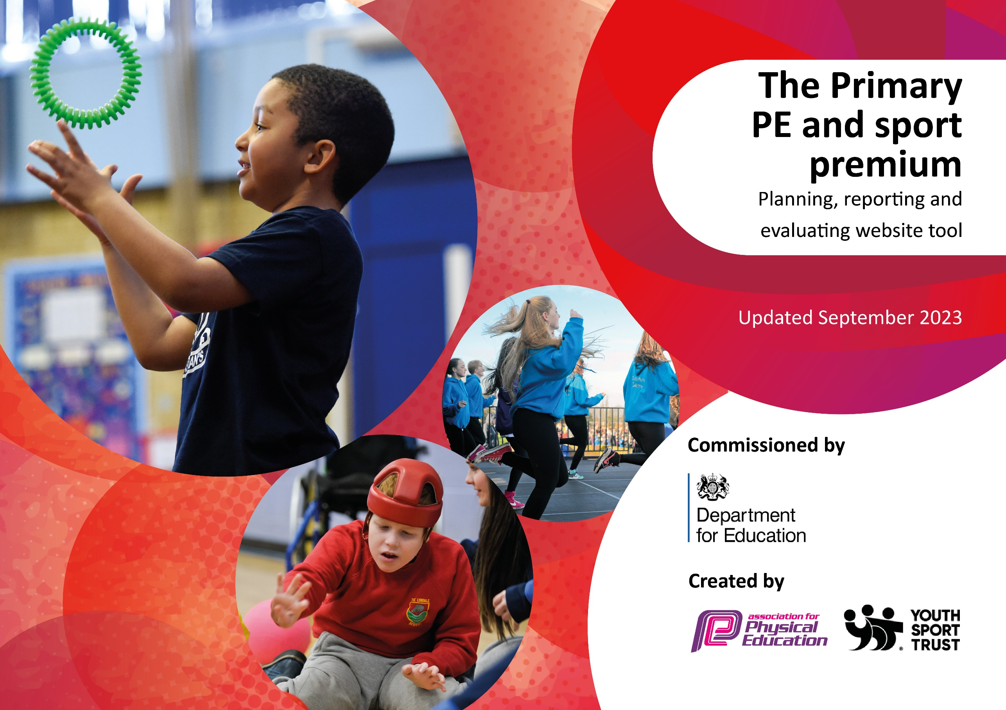

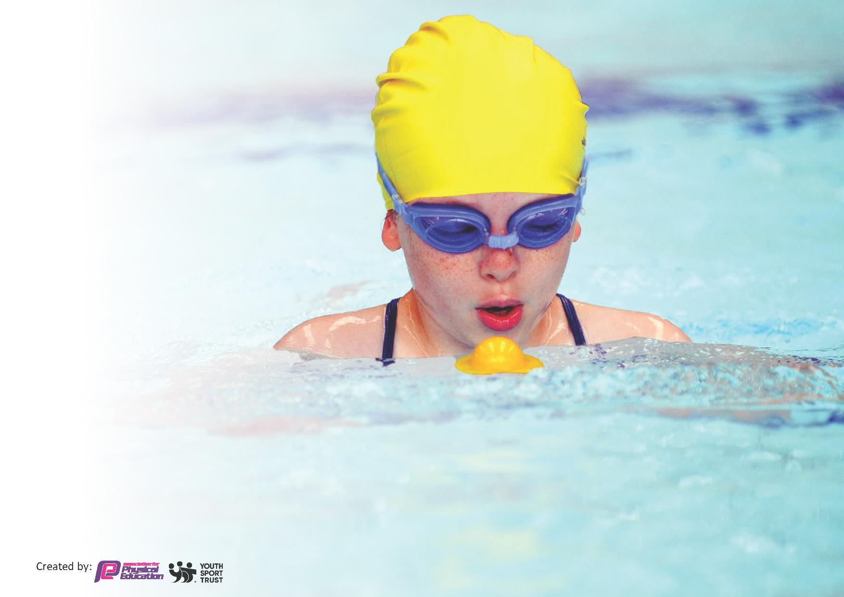
This template can be used for multiple purposes:
by:
- It enables schools to effectively plan their use of the Primary PE and sport premium
- It helps schools to meet the requirements (as set out in guidance) to publish information on their Primary PE and sport premium
- It will be an effective document to support Ofsted inspections enabling schools to evidence progress in Physical Education (PE) and evidence swimming attainment, which forms part of the PE National Curriculum. We would recommend schools consider
the Intent, Implementation and Impact of any spend, as examined within the Education Inspection Framework.

It is important that your grant is used effectively and based on school need.

Schools must use the funding to make additional and sustainable
improvements to the quality of the PE, School Sport and Physical Activity (PESSPA)
they offer. This means that you should use the Primary PE and sport premium to:

- Build capacity and capability within the school to ensure that improvements made now will benefit pupils joining the school in future years
- Develop or add to the PESSPA activities that your school already offers.

The Primary PE and sport premium should not be used to fund capital spend projects; the school’s core budget should fund these. Further detail on capital expenditure can be found in the updated Primary PE and sport premium guidance.

The Primary PE and sport premium guidance, outlines 5 key priorities that funding should be used towards. It is not

necessary that spending has to meet all the key priorities, you should select the priorities that you aim to use any funding towards.

Although completing this template is not a requirement for schools, schools are required to publish details of how they spend this funding. Schools must also outline what the impact this funding has had on pupils’ PE and sport participation and attainment and how any spending will be sustainable in the future. All funding must be spent by 31st July 2024.

The Department for Education has worked closely with the Association for Physical Education (afPE) and the Youth Sport Trust (YST) to develop this template and encourages schools to use it. This template is an effective way of meeting the reporting requirements of the Primary PE and sport premium.
Review of last year’s spend and key achievements (2023/2024)

We recommend you start by reflecting on the impact of current provision and reviewing your previous spend.

Activity/Action | Impact | Comments
Morning fitness club with PP children.  Funding allocated to sports coach to prep and teach directed sports sessions  Sport coach ABO facilities Friday provision of sporting activities for children that remain in school on Friday afternoons.  Sports coach ABO organizes (and runs the majority of) after school clubs  ABO and PE lead monitor and promote the Weekly mile and the walk to school  Sports coach takes children to sports competitions and sports festivals  Sports coach to work closely with each year group throughout the week to offer additional target provision (following government guidelines)  Sports coach supports staff with CPD training in areas such as the use of PE passport for assessment, evidencing PE, team teaching with staff to model effective lessons | Children come into school positive in a morning and have a much better attitude to the school day. Children have a better attitude to learning which helps children to start their day of learning. Attendance has boosted from the morning fitness club.  Children receive a specialist provision by ABO. New learning and activities are taken part within school. Children enjoy PE and boosts achievement and participation within PE. PE equipment is ordered and kept on top of for all years lessons throughout the year by ABO and PE lead.  ABO offers children active games to take part in with the Friday provision. This supports staff, parents and children within school. Children who attend Friday club are often happy to go and enjoy the activities.  ABO provides children with a variety of learning across their time at school with many different clubs for different ages. He then takes members of the afterschool clubs and school children to competitions for the certain sports. Children can use their knowledge and skills from afterschool clubs in their lessons. Children can find their passion in a certain type of sport.  Children are understanding of the importance of exercise and children come into class clam and ready for learning after their morning weekly mile.  Children have shown true sportsmanship and respect in competitions. They are showing a great sense of achievement and pride for what they achieve.  Staff are feeling more confident in teaching PE and self esteem has risen. ABO has shown staff hoe to vary lessons to adapt for children’s needs, with things such as space, time, resources.  Staff know how to evidence and assess children on PE passport. PE lead and ABO are monitoring PE Passport | Many teachers are happy with how children come into school after their morning fitness club. Children have stated that they enjoy that to start the day. Parents have commented about how much children enjoy coming to school knowing that they are going to the fitness club.  Teachers find it beneficial to have ABO to show them and model effective teaching for PE with them. He has shown teachers new games to use which link to the current aim of the lesson for circumstances when the weather effects PE outdoors.  Children and parents have great engagement with afterschool clubs and they are often full to capacity every time. Something that will be looked at this year is the engagement of Pupil premium children and potentially lower the cost for after school clubs.  Teachers can see children are more focused in lessons after the weekly mile.  Staff are pleased to be able to cater for all needs and abilities of their class in their lessons.  Further CPD for staff has been requested to ensure the confidence of staff is secure.

Key priorities and Planning
This planning template will allow schools to accurately plan their spending.

Action – what are you planning to do | Who does this action impact? | Key indicator to meet | Impacts and how sustainability will be achieved? | Cost linked to the action
ABO to provide PE staff CPD training and provide staff with coaching  The provision of PE is progressive in both knowledge and skills. It is consistently taught and offers a broad and balanced curriculum.  ABO / SLT celebrates children in assembly for taking part in new activities and for representing. Sport features in termly curriculum news letters and with themed days/ events such as sports day, dance festivals, walk to school week and sports relief  PE Curriculum offers pupils a broad range of sports in addition to ABO an other staff offer children after school clubs that change termly. Staff boost children’s activity in the Travel tracking app of walking to school.  ABO ensures the school takes part in a variety of competitions for sporting events and SEND sporting festivals. Inter- MAT competitions will continue go ahead within school.  To develop oracy skills in PE to support pupils to articulate their ideas clearly and embed subject specific vocabulary. | to ensure all staff feel confident in teaching PE.  Model effectively. Support staff with catering for all the needs and abilities of all children.  Children are provided with a wide range of physical activity. It encourages all children to participate with the variety of learning which encourages children to find their passion in sport  Raises the profile of PE meaning more children was to strive for success in PE and participate. All pupils become more engaged.  Children are offered a range of activities. Children understand more about healthy bodies and the importance of physical exercise on their wellbeing. Upskills staff in their knowledge and understanding of the curriculum  Children are offered a wide range of opportunities to develop their sporting attitudes (sportsman ship). Showing respect for others while taking part in school.  Children will be able to articulate their understand of sport and PE. Staff will be upskilled to provide meaningful language lessons to all students. | Key indicator 1 Increased confidence, knowledge and skills of all staff in teaching PE and sport  Key indicator 2 -The engagement of all pupils in regular physical activity  Key indicator 3 The profile of PE and sport is raised across the school as a tool for whole school improvement  Key indicator 4: Broader experience of a range of sports and activities offered to all pupils.  Key indicator 5 Increased participation in competitive sport  Key indicator 1 Increased confidence, knowledge and skills of all staff in teaching PE and sport | High quality provision of PE across school will be achieved. Boost staff confidence in PE. Consistency for all children’s learning.  Children could find hobbies and progress them outside of school. Staff will follow the long-term plan. PE lead and sports coach will monitor  More pupils participate. ABO to continue to promote sports across school, continue the communication with parents about sporting activities in school.  PSHE and PE lead to monitor the progress of the travel tracker within the school. PE lead and ABO will check termly with staff to ensure engaging physical activities are completed as after school clubs. ABO and PE lead to ensure a variety of sports festivals and events happen in school  ABO will be continuing to enroll perry hall in a range of competitions as well as PE lead.  PE lead and ABO to deliver CPD to staff to model effective strategies for activating key vocabulary in PE.  PE lead and ABO in learning walks, assessment and pupil voice. | Funding all spent on AB costs: £19,570

Key achievements 2024-2025
This template will be completed at the end of the academic year and will showcase the key achievements schools have made with their Primary PE and sport premium spending.

Activity/Action | Impact | Comments
Put down key achievements at each term:  End of Autumn term  CPD offered  Clubs  Tracking of pupil voice  Monitoring pe passport  Spring Term:  Work closely with staff modelling the use of PE passport  Ensuring people are doing the weekly mile as well as the 1 hour PE time  CPD to be offered to different staff members  Summer  To boost vocabulary and oracy in PE for children to talk about and explain what they are doing in each lesson | AB has worked alongside staff especially those in Year 2, Year 1, Reception and Year 4 to support the staff in using PE passport and ways of teaching the children. If that be through scaffolding learning or challenging learning. He has also shown the progressive steps in the areas of PE.  EB has carried out Pupil voice with 4 year groups. Lots of positives came back from that. Children are enjoying PE and are wanting more PE time. They enjoy the clubs provided and could explain what they have learnt in PE well. When talking to children it was clear to see that scaffolds were in place for children to make them feel more confident about PE even when they find something tricky.  After monitoring PE passport, some staff just need a reminder to upload evidence for all lessons, even if its indoor PE due to the weather, which EB is going to do in Spring and offer staff support in using and navigating PE passport.  AB has worked alongside class teachers to model effective use of PE Passport in lessons, including how to access curriculum plans, assessment tools and progression maps. EB followed up with individual staff to troubleshoot any gaps in recording or planning so that PE Passport is now being used more confidently and more accurately across year groups.  Some classes are now consistently doing both the weekly mile and their full PE allocation, but this is not yet fully embedded across the whole school, particularly during busy curriculum weeks or when the weather has impacted outdoor opportunities. Further action is needed to secure full consistency.  Stronger focus on subject-specific vocabulary within PE lessons by modelling key terminology and ensuring it is displayed and referred to throughout the lesson. EB encouraged teachers to prompt pupils to explain skills using correct language. | Staff are feeling more confident with PE lessons and how to vary lessons to support all children.  Children are enjoying PE and swimming is having a really big impact for all children after listening to Year 6 pupil voice, they are making so much progress.

Swimming Data
Meeting National Curriculum requirements for swimming and water safety.
Priority should always be given to ensuring that pupils can perform safe self-rescue even if they do not fully meet the first two requirements of the National Curriculum programme of study

Question | Stats: | Further context  Relative to local challenges
What percentage of your current Year 6 cohort can swim competently, confidently and proficiently over a distance of at least 25 metres? | 62% | Of this 62%, 11% (4ch) are PP.
What percentage of your current Year 6 cohort can use a range of strokes effectively [for example, front crawl, backstroke, and breaststroke]? | 57%

What percentage of your current Year 6 cohort are able to perform safe self-rescue in different water-based situations? | 51%
If your schools swimming data is below national expectation, you can choose to use the Primary PE and sport premium to provide additional top-up sessions for those pupils that did not meet National Curriculum  requirements after the completion of core lessons. Have you done this? | Yes/No
Have you provided CPD to improve the knowledge and confidence of staff to be able to teach swimming and water safety? | Yes/No

Signed off by:

Head Teacher: | Lee Fellows (Headteacher)
Subject Leader or the individual responsible for the Primary PE and sport premium: | Ellie Ball (PE Lead)
Governor: | Darren Collingswood (Chair)
Date: | 07.07.25

