**Year 2**



**2020/2021**

**Holiday Transition Activities**

Please send any of your completed tasks by Tuesday 1st September 2020. Email:

[ph.y2homelearning@perryhallmat.co.uk](mailto:ph.y2homelearning@perryhallmat.co.uk)

Summer Reading Challenge

Your Year 2 teachers have been busy reading the books below. See the links on the school website to hear them read the first couple of pages!

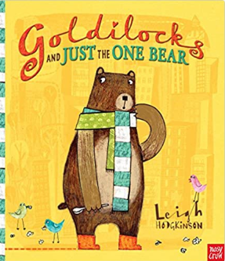

Peace at Last Goldilocks and just the ???/???

One Bear

By Jill Murphy By Leigh Hodgkinson By David Walliams

Your challenge is to read the same books and vote for your favourite. Remember to think of 3 reasons why! Send your answers to the Year 2 email address above by the First Day back after the holiday!