Use as many of the skills you have learnt since September as you can. | Year 2  The year so far… | To be completed over the coming weeks.
The Writer  - Can you write your own twisted tale? Think back to The True Story of the Three Little Pigs or Goldilocks and Just One Bear. Which characters from other fairy tales can you use instead?  - Can you create a fact file about one of the big five in Africa?  - Write a script and perform an item for a travel show about why Kenya would be a good place to go for a holiday. | The Geographer  - Research the following points about Kenya; the capital city, the population of Kenya, what the weather and climate is like, what is special about the culture, which rivers and mountains there are and which animals you will find there.  - Can you create a leaflet about visiting Kenya using the points above?  - What does migration mean? Can you find out why animals migrate across Africa? Can you explain what ‘endangered’ means and why animals in Africa may be endangered? | PE  - Whilst playing catch, how many other countries in Africa can you name? Can you include any rivers, mountains or seas?  - Research some Kenyan dance moves and see if you can create your own dance to Kenyan music. How many members of your family can you get to join in with you?  - Animal tennis – how many African animals can you and a partner name in 1 minute?
The Builder  - Can you build an elephant using a plastic milk bottle and collage materials or with paint?  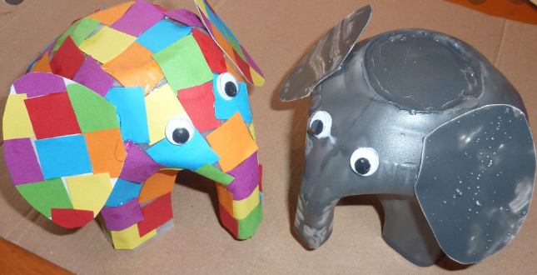  - Can you collect some natural materials and make the flag of Kenya?  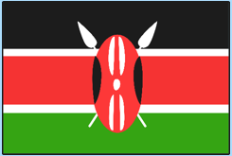 | The Mathematician  - Can you create an obstacle course and time how long it takes to complete it? Can you find the difference between your quickest time to your slowest time? Can you compare times with other family members?  - Find or create a map of a national park in Kenya? Can you direct a family member to certain points of your park using compass directions N, E, S & W?  - Can you draw a bar chart showing the timings of your boat travelling across the water from your science experiment? | The Scientist  - Using junk modelling items at home, make a boat that will float on water from one side to another and time how long it takes.  - Investigate different materials which will be the best for your boat and explain why referring to their properties.  - Write up your science investigation using scientific language and with the following headings: What do I want to find out, what I will need, my prediction, a diagram, what I will keep the same, what I will change, the results and a conclusion.

