Please complete each activity to support your learning. | Year 1  Summer term
This time our home schooling activities are based around the story of George and the dragon by Chris Wormell.  Listen to the story on YouTube:  (https://www.youtube.com/watch?v=3Dejq-XAOY4)  Then have a go at the activities. | 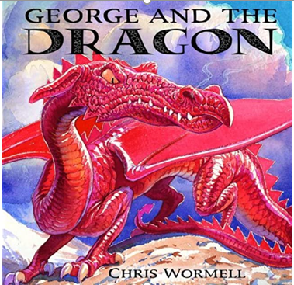 | Can you draw or make a home for one of the main characters?  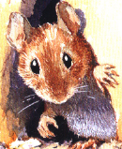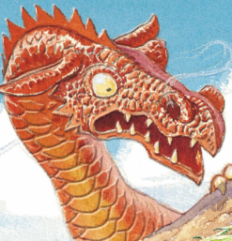
Last time we looked at flags of the United Kingdom.  This time we would like you to make your own flag.  Remember it needs to tell us about you so you can include things you are good at or things you like to do.  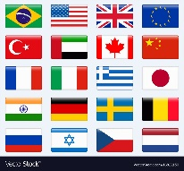 | Have a go at making your own fire breathing dragon. You will need  -1 paper roll (toilet roll or kitchen roll)  -Green or red tissue paper  -2 large pom poms (eyes)  -2 small pom poms (nostrils)  -1 glue stick  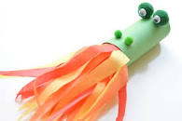 | Research mice on the internet.  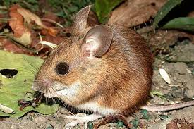  Find and record five facts about them to create a fact file.  Try and include information about where they live, what they like to eat, what they look like and don’t forget a ‘fun fact’ to finish your fact file!
Ask a grown-up to help you make hard-boiled eggs. Once they have cooled, paint the shells or decorate them with craft materials to create your own dragon eggs.  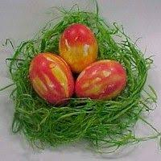  - Can you create a nest for your dragon eggs? What materials will you use?  - Have a go at writing a list of instructions about how to cook a hard-boiled egg. | Read through the story again  How many adjectives can you find to describe the dragon?  Make a poster with a picture of the dragon and the words around it.  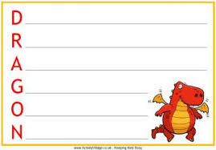  Use some of the adjectives you thought of to create an acrostic poem about the dragon. | In Modern Foreign Language we are learning Spanish.  Find out how to say ‘mouse’ in Spanish. What other animal names can you learn in Spanish?  