Please complete each activity to support your learning. | Teriffic for Twos  Home Learning
Talk to your grown up about the story, see if you can predict what will happen next.  Can you recall and retell the story to your grown up.  Have a go at drawing a bear with your grown up.  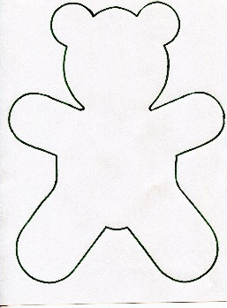 | Read Goldilocks and the Three Bears with your grown up.  Use this link: https://www.youtube.com/watch?v=qOJ_A5tgBKM  Talk to your grown up about your favourite breakfast, try tasting porridge with different toppings, or have a go at creating your own tasty teddy bear toast.  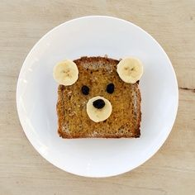 | We sing lots of different nursery rhymes in Twos, at the end of your story sing some of your favourites songs with your grown up or try a new song. See some examples below:  Teddy Bear, Teddy Bear, turn around.  Ten in a bed  Five Little Ducks went swimming one day  Wind your bobbin up  Head, shoulders, knees and toes
Try potato paw printing with your grown up. All you need is:  - A potato cut in half  - Brown paint  - Paper plate  - Paper  - A knife for your grown up to cut out the shape  - Ask your grown up to cut the potato in half  - Draw the shape of the paw using a pen  - Your grown up can cut out the paw shape.  - Put some paint onto your paper plate.  - Place your potato shape onto the paint.  - Take the potato off the paint and begin to print your paws on a piece of paper.  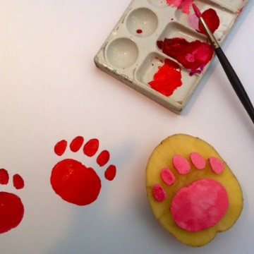 | Have a Teddy Bear picnic at home or in the garden.  Try looking for objects that are in the story around your house; count how many chairs, beds, bowls and spoons can you find.  You could make an opposites box: learn about hard/soft or rough/smooth everyday objects  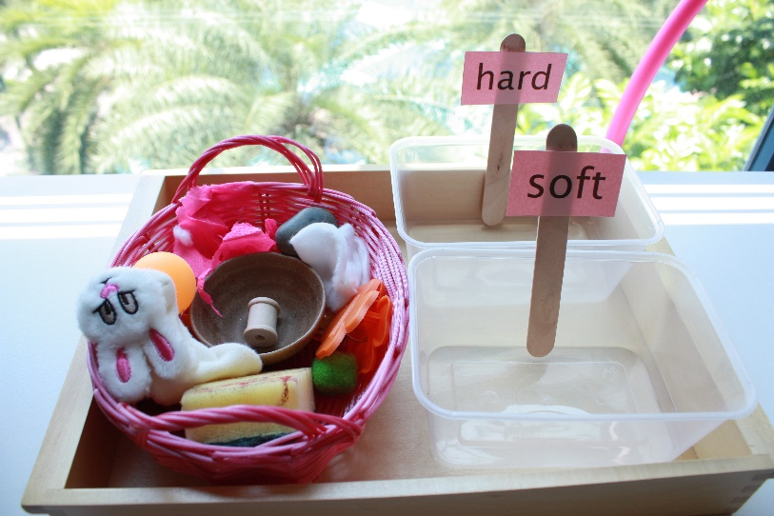 | You could create your own bears from playdough, try adding peppermint/vanilla essence to make it scented. You could use raisons for the eyes, maybe buttons for the ears.  Try and make bear shaped biscuits.  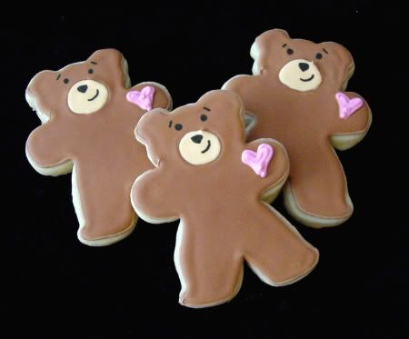  Have a go at threading cheerios onto straws or laces, see how many you can count.  Try and have a go at the counting chart, see if you can count the objects one to three first.  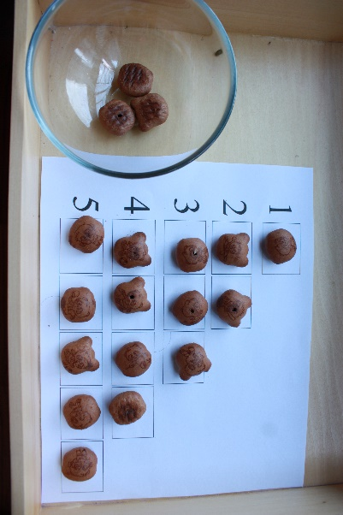
Can you recall and retell the story to your grown up. | At the end of the story Goldilocks runs away from the bear house:  Can you play hide and seek with a doll and your family | Can you make different faces with your grown up, show your happy, sad, angry, silly faces [grown ups – this helps children to dentify and explore there feelings]  Role play: try and dress up and act like a grizzly bear, you could make a bear mask to help with this.
Practice your letter formation. Practise examples can be found on the home learning page on the school website. | Practise counting from 1 – 5. Ask your grown up to write the numbers 1-5 on paper so that you can see them too. See if you can go up to the number 10!  See if you can go up to the number 10! | Have a go at tracing your name. Ask your grown up to write out your name so that you can trace around it.

