Please complete each activity to support your learning at home. | Nursery Home Learning  Bears | 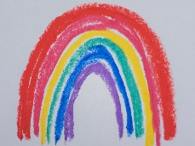
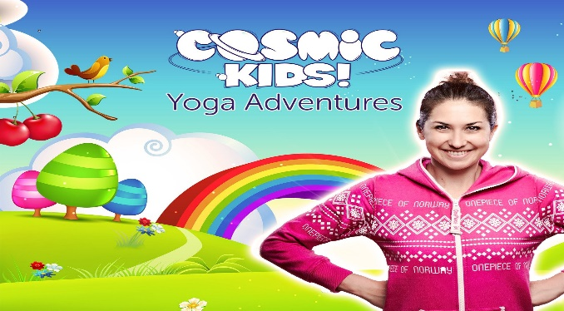  Cosmic Kids help children become. . .  Stronger  Calmer  Wiser  Try this at home https://www.youtube.com/user/CosmicKidsYoga | 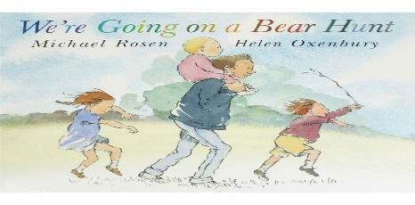  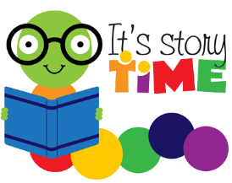  This Home Learning grid encourages you to join in with activities based upon the story We’re Going on a Bear Hunt.  Watch this link to hear the Author share his story with you.  https://youtu.be/0gyI6ykDwds  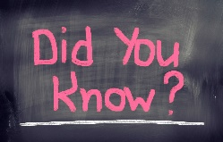  An Author – write stories. The author of this book is called Michael Rosen. | 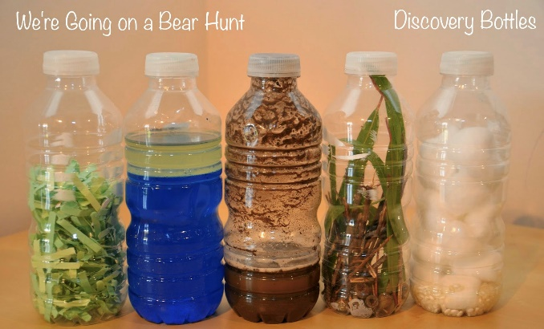  Create your own ‘We’re Going on a Bear Hunt’ discovery bottles using empty plastic bottles.  What could you use to represent grass? The river? Mud?  A forest? Snowstorm?
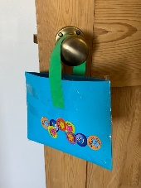  Go on a treasure hunt, what treasure can you find?  First create your treasure bag.  Here’s a picture to give you an idea. You can be as creative as you want. Ask a big brother or sister to help, or a grown up.  - What treasure can you find around your home?  - In your garden, or outside space?  - When you go for your local walk?  Fill your bag, ask an adult to share your photo’s ph.eyfshomelearning@perryhallmat.co.uk | Talk to your grown up about the story.  Questions to think about  - Do you have a favourite part of the story?  - Can you talk about what happens in the beginning, middle and end of the story?  - Are you able to join in with the repeated refrains?  - What do you think the family’s next adventure might be?  - I wonder what the bear in the cave looks like. . .perhaps you could draw me a picture  - What is your favourite story at home? | Over, under through challenge  Have a look around your home  Find some objects you can travel over, under or through. Tell your grown up whether you travel ‘over’, ‘under’ or ‘through’ the objects.  Here are some ideas. . .  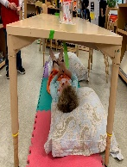  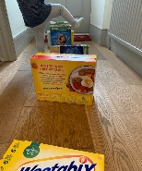  Over. Under. Through.  We look forward to seeing your photo’s
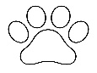  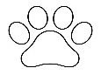  If you could search for an animal with your family . . .  Which animal would it be?  Where would you go to look?  What clues would look, listen, smell, touch for?  What would you do when you found it?  You might want to make some binoculars to help you search | 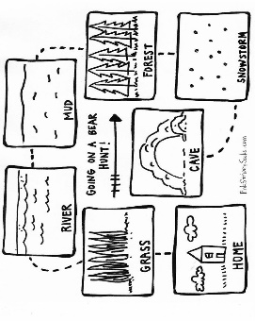  Create a story map with your family about a story.  See if you can create a story map. There are a couple of examples above. A story map uses images or prompts to help children to re-tell a story.  Create a story map of your favourite story. | Create your own paint using flour or mud!  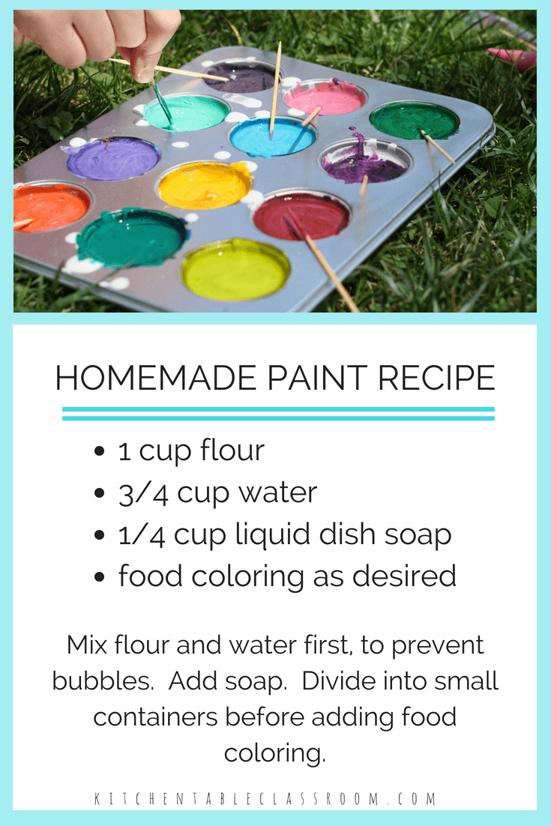  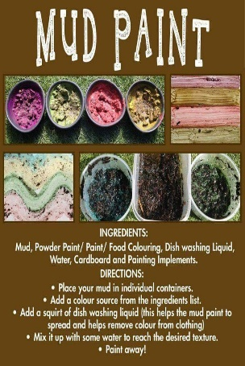  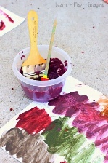  Send us your paintings
Practise writing the sounds you have been learning,  Practise writing your first and surname. | When looking at books see if you can spot any of the sounds you know in the text.  Can you guess what might happen at the end of the story? | We have focused lots on hunting.  Ask your grown-ups to hide some 2-D or 3-D shapes around your home.  Can you name them? How do you know?  Count the corners? Count the sides?

