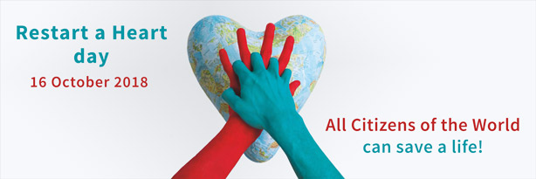

Wednesday 3rd October 2018

Dear Parent / Carer

Restart a Heart Day – Tuesday 16th October 2018

Tuesday 16th October 2018 is Restart a Heart Day, an annual event to teach as many people as possible the lifesaving skill of CPR. We are very pleased to inform you that we are able to offer our Year 5 and 6 pupils the opportunity to take part this year.

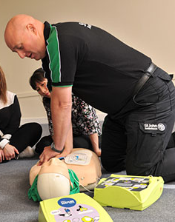
In order to educate as many members of the public as possible, St John’s Ambulance volunteers will teach pupils how to help restart the heart of someone who has suffered a cardiac arrest.

They will come into school on Tuesday 16th October and provide CPR demonstrations to pupils. This is a fantastic opportunity for your child to learn an invaluable lifesaving skill.
All St John Ambulance volunteers regularly practice CPR as part of the charity’s intensive first aid training and many have used their skill to save a life – so they are among the best people to pass on the skill to others.

Please could you complete the permission slip below and return to your child’s class teacher by Friday 12th October 2018.

Please do not hesitate to contact us if you need any further information.

Yours sincerely,

Miss Kohli

Executive Headteacher

____________________________________________________________________________

Restart a Heart Day – Tuesday 16th October 2018

I do / do not give permission for my child ____________________________ in class _______ to take part in Restart a Heart Day on Tuesday 16th October 2018 and be involved in CPR demonstrations- a fantastic opportunity to learn an invaluable lifesaving skill.

Signed: __________________________________ Date: __________________

