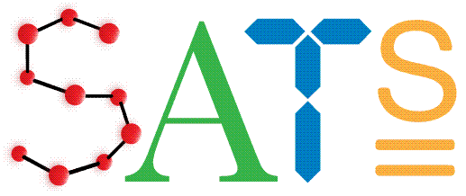
28th March 2018

Dear parents/carers,

Your child has worked exceptionally hard this year and we fully appreciate that they need lots of rest and recuperation over the Easter break. However, when we return to school the SATs tests will soon be upon us therefore we recommend that your child ‘keeps their brain ticking over’ so as not to hinder all of the hard work they have put in so far.

They can achieve this through a variety of ways- whichever is their preference:
- Completing this week’s homework
- Tackling the ‘My Maths’ activities that have been set online
- Engaging with some of the revision material that we provided following the
SATs Workshop a few weeks ago
- Reading their reading book or any other reading material they have at home
- Browsing the BBC bitesize KS2 website:
https://www.bbc.com/education/levels/zbr9wmn

We hope your child enjoys their well-deserved rest and that you have a great Easter break.

Thank you once again for your continued support.

Miss Kohli
Headteacher

