Tuesday 27th March

Dear parents/carers,

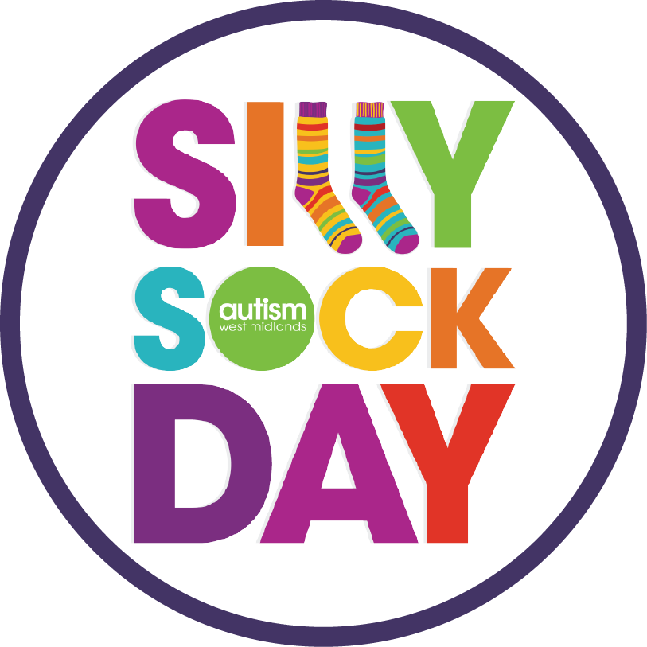
Following on from the success of last year’s Silly Sock Day and to mark the end of world autism awareness month (April), Perry Hall will be joining ‘Autism West Midlands’ to once again host a Silly Sock Day, on Friday 27th April to raise money for Autism West Midlands.

It is really easy to take part! All children have to do is come to school in their normal school uniform, but wearing their silliest, craziest, wackiest socks- the more outrageous the better!

Each child is asked to donate £1. All of the money raised from your snazzy efforts will help the charity provide vital services and go towards supporting people with autism and their families in the West Midlands. Please join in with this fun fundraiser if you can.

Yours Sincerely,

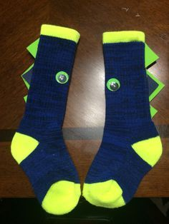
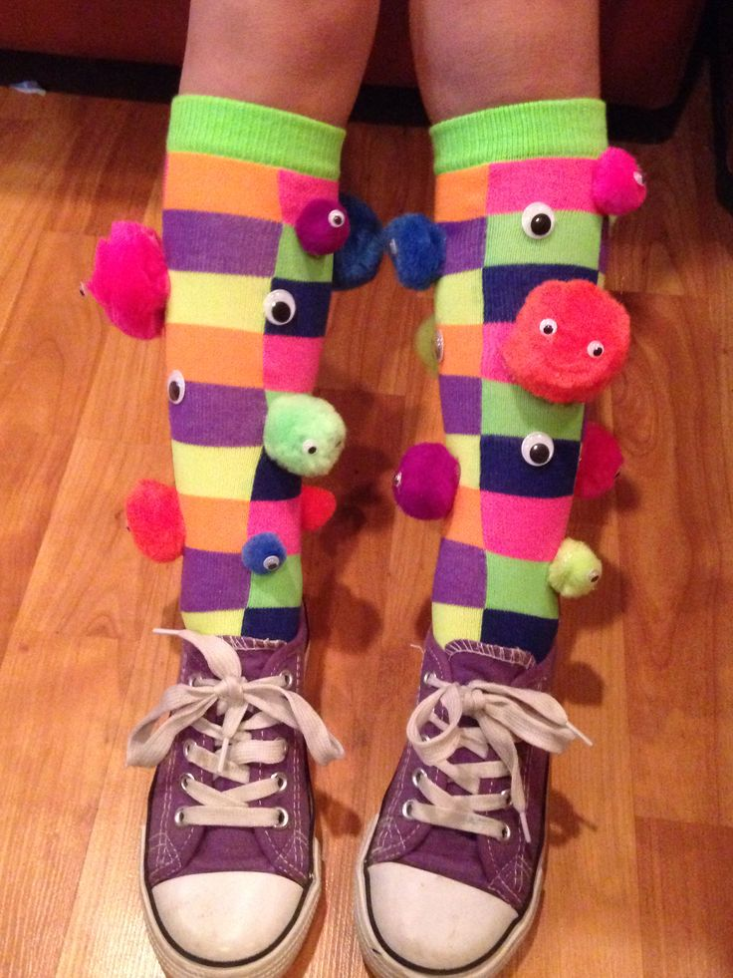
Miss Kohli
Head Teacher


