________________________________________________________

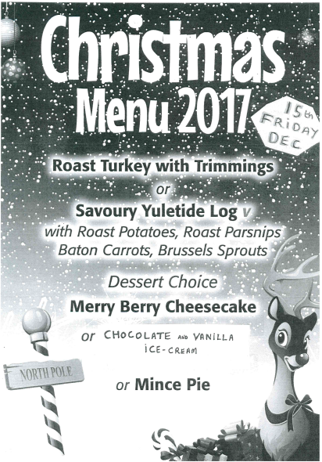
8th December 2017

Dear Parent/Carer,

Christmas dinner for the children will be on Friday 15th December. The price of which is £2.40. The kitchen staff need to know numbers as soon as possible. If your child would like a Christmas dinner, please complete the slip below and return it to school as soon as possible and no later than Wednesday 13th December.

Thank you.

Yours sincerely,

Mrs C Gibbins
Deputy Head teacher

---------------------------------------------------------------------------------------------------------------------------
Christmas Dinner
Friday 15th December 2017

I would like to order a Christmas dinner for:

Name of child: ………………………………………………………………….. Class: ………………………………….

Signed: ……………………………………………………………………………….. Parent/Carer

Date: ……………………………………………………..

