________________________________________________________

17th November 2017

Dear Parent/Carer,

On Friday 24th November we will be running a Wear Your Stripes Day to support Brake, the road safety charity.

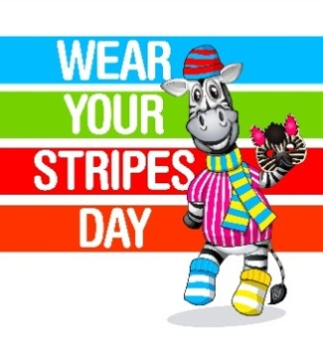
We are running this fundraiser by asking children to dress in fun, bright, stripy clothes and donate £1 each which we will forward onto Brake.
Please don’t forget to dress your children up and support the day!

This is a fantastic dress-down day where children can dress like Brake’s mascot Zak the Zebra. They can opt for traditional black and white stripes, accessorise with colourful striped garments or even make their own zebra mask!

The day is also a great way for us to promote road safety as well as raise funds for Brake’s work supporting families affected by road crashes and campaigning for safer roads.

A child is hurt or killed every 33 minutes on UK roads. Please supervise your child closely on roads and continue to teach road safety as we hope you already do. In particular, always:
- cross roads safely with your child, using it to teach the Green Cross Code
- ensure your child holds an adult’s hand around roads, until they are at least eight
- in cars, ensure your child is buckled up in a child restraint suitable for their size and weight until they are 150cm tall
- if you drive, go 20mph or below around homes, schools and shops, with respect for other people’s children.

Please go to brake.org.uk/families for more advice about keeping your child safe on roads.

Thank you for supporting our Wear Your Stripes Day,

Yours Sincerely,

Mrs Gibbins

Assistant Head Teacher

