**Governor Newsletter Spring Term 2018**

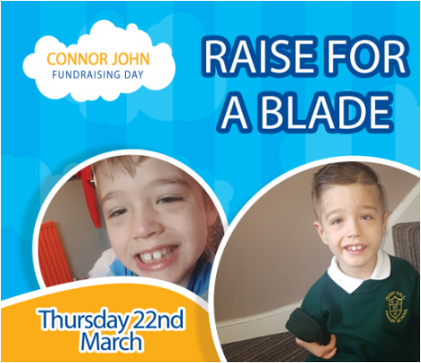**Spring Term Highlights 2018**

***What have the Governing Body been up to?***

*We have continued to attend meetings with staff and have also took part in some of the many training courses on offer to us as governors. Link governors have particularly enjoyed visiting school to meet individual staff within a range of roles, so that we have a full understanding of every aspect of Perry Hall.*

**Safeguarding**

It is impossible to overstate just how important this is to each and every one of us. During the Spring Term, an independent audit of safeguarding was carried out at Perry Hall. Feedback from this showed that not only does the school deliver outstanding safeguarding practice but continues to strive to improve. E-safety is also a key part of our Computing curriculum and workshops for parents are offered to support this.

**Trips and Residentials**

Our pupils have been able to enjoy a variety of trips this term including Year 4’s visit to Cadbury World and Nursery’s visits to Kingswood. All were enjoyed by the children and offered them a range of new experiences.

**Attendance**

To date, attendance this term has been 94.4% against the national average of 96%. Again, we would like to thank parents/carers and the children for their efforts to achieve 100% attendance this term, especially given some of the very poor weather we have experienced recently.

**Social, Moral, Spiritual and Cultural Activities**

Naturally, during the Spring Term, Easter has been the focus of spiritual activities but it has also been particularly heart-warming to see everyone’s generous efforts to raise money for Connor-John. Perry Hall aims to provide a very inclusive environment for all staff and pupils and the Connor- John Day really demonstrated how the pupils of Perry Hall care about each other.

**Parent Workshops**

The focus of recent workshops has been on phonics and SATS. They have provided a great way of finding out how you can support your children’s education. Please keep an eye on the weekly newsletter for upcoming workshops next term, which we hope you will be able to attend.



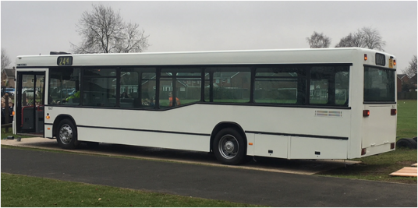

**Comments**

Thank you so much for all of the feedback you provided us with at parents evening in February. In particular, we were really pleased that the improvements to the Good to be Green scheme have been recognised as successful and also that so many parents are happier with the improved communications via school. Feedback from parents is essential as Perry Hall strives to offer our children the best possible education.

If you do have any further comments, contact can be made with us in writing to the school, addressed to Damian Tarbuck– the Chair of Governors.

**And finally….**

*We hope that you have a very enjoyable Easter break*

**Come and Meet Us!**

During the Summer Term, we will be holding a forum to give parents the opportunity to meet several governors and members of staff to discuss topics such as homework and parent workshops. The dates of these parent forums will be shared at the start of next term- we look forward to meeting as many parents as possible and really hope that you will be able to attend.

**Reading Bus**

Our reading bus finally arrived in January and generated much excitement amongst pupils and staff alike. We have already received many generous donations but we are not there yet. If you would like to help out with this exciting project, either through donation or by being able to help out with the work required, please contact the school office.

**Curriculum**

World book Day and STEM week have been just two of the highlights of the Spring Term. Science has become an increasingly prominent part of the National Curriculum over the last couple of years and so it was great to see so many exciting science projects being proudly brought into school.

